**Installing Playwright in project folder**

This guide explains how to set up Playwright in a new project folder using Visual Studio Code and Node.js.

1. Create a new folder on any drive. For example, I created a folder named playwright-tutorial on the **D:** drive.
2. Open **Visual Studio Code**, then go to **File → Open Folder**, and select the folder you just created.   
     
   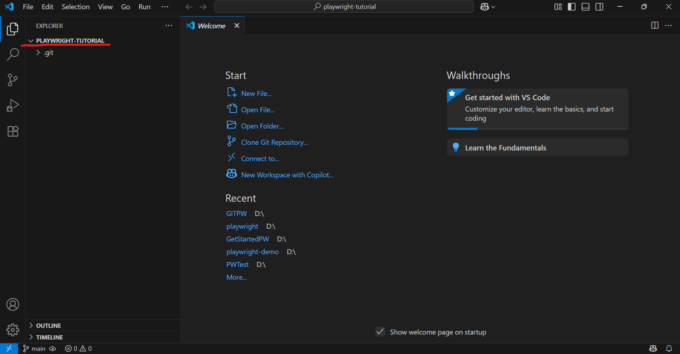
3. In VS Code, click the **three-dot menu (…)**, then select **Terminal → New Terminal** or use the shortcut Ctrl+` to open the terminal.
4. In the terminal, type the following command and press Enter:  
   ***npm init playwright@latest*Choose the following options**:  
   a) Select "JavaScript" as the language.  
   b) Press Enter to accept the default test folder: `tests`  
   c) For "Add a GitHub Actions workflow?", type `true`  
   d) Press Enter to install Playwright browsers (accept default: `true`)
5. After installation, Playwright will generate the following:
   1. package.json
   2. playwright.config.js
   3. tests/example.spec.js (a sample test)
   4. tests-examples/demo-todo-app.spec.js (another sample test)
   5. Downloaded browsers in the .playwright directory
   6. The node_modules/ folder with dependencies
6. You’re now ready to start writing and running your own Playwright scripts!